Ichinomiya Town 1st Route (Fiscal year 2024)
(1～10 Ward)
How to separate and dispose of waste and recyclables
*Dispose all Waste on the designated days between 5:00 am and 8:30 am
*Any waste from Businesses is not accepted
◆Burnable Waste Collected every Tuesday, Thursday, and Saturday including Holidays, but it will not be collected between December 29 and January 3.
Dispose all Burnable Waste in the Designated Blue Disposal Bags.
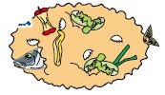
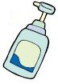
・Paper Diapers (Flush used Paper Diapers in the toilet)
・Plastic Dispensers
・Organic Waste (Drain all liquid first)
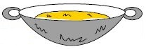
・Cooking Oil (Dispose it after solidifying or absorbing with Paper Towels / Newspapers)
・Used Hand Warmers / Body Warmer Packs
・Video Tapes / Cassette Tapes / CDs / DVDs
・Toys (including Plastic Toys)
・Weeds / Flowers
・Leather Goods that fit into the disposal bags
・Lighters (Dispose only after completely used, and only 1 per bag)
・Footwear
・Styrofoam (Crush it and put it into the Designated Burnable Disposal Bag. It cannot be disposed as Oversized Waste)

Case when the Designated Blue Disposal Bag is not necessary.
・Small Twigs only (less than 50 cm in Length and less than 5 cm in Thickness)
‐Stack them together (Stack less than 30 cm in Diameter)
‐2 stacks per collection (If disposing more than 2 stacks, put them into the Designated Blue Disposal Bag)
‐It cannot be disposed as Oversized Waste
◆Recyclable Waste Collected every 3rd Friday of the Month.
Apr. | May | Jun. | Jul. | Aug. | Sep. | Oct. | Nov. | Dec. | Jan. | Feb. | Mar.
19 | 17 | 21 | 19 | 16 | 20 | 18 | 15 | 20 | 17 | 21 | 21
*The Designated Containers and Net Bags will be placed at the Waste Collections Area the day before.
・Batteries
‐Dry-Cell Batteries are collected on Jun. 21, Oct. 18 and Feb. 21.
‐Place Dry-Cell Batteries into a Clear Bag and label it 【乾電池】.
‐Recycle all Rechargeable Batteries in the Collection Box at an Electronics Store.

・Spray Cans and Gas Canisters
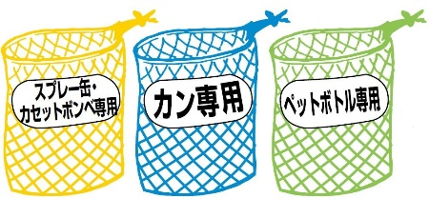
‐Use all of the contents and put the Spray Can or Gas Canister into the Designated Yellow Netted Bag without puncturing a hole in it.

・Steel and Aluminum Cans
‐Wash the can with water before putting it into the Designated Blue Netted Bag.
‐Cans that were non-food related products, pesticides, or reused should be disposed as the Non-Burnable Waste.
‐Caps and Lids should be separated into Burnable or Non-Burnable Waste according to its material.

・Plastic PET Bottles
‐Take off the cap and label, wash thoroughly with water, and place it into the Designated Green Netted Bag for Plastic PET Bottles.
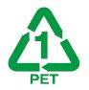
‐Only for food and drink containers with the plastic mark. All other Plastic Bottles, Egg Packs, Pesticides, and Reused Plastic Bottles should be disposed as Burnable Waste.
‐The cap and label are disposed as Burnable Waste.

・Bottles
‐Take off the cap, wash thoroughly with water, and put into the baskets separated into Clear Bottles, Brown Bottles, and Other Colored Bottles.
‐Bottles that were non-food related products, pesticides, or reused should be disposed as Non-Burnable Waste.
‐Return beer bottles and 1 sho Bottles (1.8 liter bottles) that are reusable to the store you bought it from.
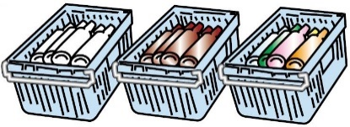
‐It is not necessary to take off hard to peel labels or the metal ring.
‐Caps should be separated into Burnable or Non-Burnable Waste according to its material.

・Paper Products
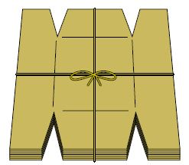
‐Tie each Paper Product together based on their type. On rainy days, wrap the Paper Waste in a Clear Bag so that the contents can be seen without getting wet.
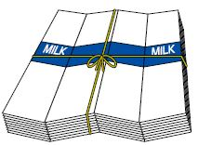
‐Newspapers (Stack only Newspapers and Flyers together.)
‐Cardboard Boxes
‐Paper Cartons
‐Magazines (Dispose Dictionaries and Thick Paper in Burnable Waste.)
‐Other Paper products including Paper Containers and Wrapping, Packing Paper, Empty Boxes and Other products
‐Toilet Paper, Wraps, and other items are adhesive when made so they cannot be recycled. Dispose these items into Burnable Waste.

・Clothing
‐Sheets, Blankets, and Summer Blankets (similar to a towel) that do not have cotton should be placed into Recyclables.
‐Items that cannot be disposed as Clothing items → Curtains, Cushion, Pillows, Worker's Short Coats, Kimono, Shreds of Cloth, Bath Mats, Carp Streamers, Car Covers, Stuffed Animals, Winter Gear (Ski Wear and Down Jackets) and etc.
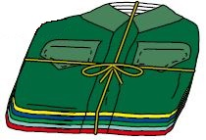

◆Non-Burnable Waste Collected every 4th Friday of the Month.
Apr. | May | Jun. | Jul. | Aug. | Sep. | Oct. | Nov. | Dec. | Jan. | Feb. | Mar.
26 | 24 | 28 | 26 | 23 | 27 | 25 | 22 | 27 | 24 | 28 | 28
Dispose all Non-Burnable Waste in the Designated Clear Disposal Bags.
・Kettles, Fry Pans, and Pots
・Non-Recyclable Bottles, Glasses, Cans, and Ceramics (Empty Makeup Bottles and etc.)
・Wire Hangars (Wood and Plastic Hangars should be disposed in Burnable Waste.)
・Dispose Ceiling Light Bulbs, Broken Glass, Sharp Objects, and etc. after wrapping in Paper Towels / Newspapers.
・Foldable Umbrellas
◆Oversized Waste Collected every 2nd Friday of the Month.
Apr. | May | Jun. | Jul. | Aug. | Sep. | Oct. | Nov. | Dec. | Jan. | Feb. | Mar.
12 | 10 | 14 | 12 | 9 | 13 | 11 | 8 | 13 | 10 | 14 | 14
Only dispose of items that are less than 20 kg, that are less than 1.8m long, and that can be held by one person
・Plastic Storage Box for Clothing
・Oversized Light Fixtures (Dispose of it in an empty case/box)
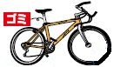
・Bicycles / Strollers / Baby Cars (Put a tag that states 「ゴミ」 on the handles of Bicycles, Strollers, Walkers, Unicycles and other similar vehicles that are disposable. Items without the tag will not be collected.)
・Printers
・Stereos, CD Players
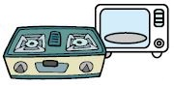
・Electric Fans
・Microwaves, Gas Range
・Vacuums
・Stove (including a Gas Fan Heater, and Remove all Batteries and Gasoline)
・Gas Tank (Take off the Cap and Only for Tanks without any contents inside)
・Blinds, Screens, Tin Metal Sheets, Carpets (Cut oversized Carpets into 20 kg pieces)
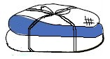
‐It should be tied with string and up to 3 at one time
・Futon and Bed Mats (Only for mattresses without springs and that are foldable)
‐Limited to 2 items per regular household
・*Laptops and Recyclable Home Electronics Appliances (including Televisions, Refrigerators, Freezers, Washer Machines, Dryers, and Air Conditioning Units) cannot be disposed at the Waste Collections Area.

Items disposable through the Waste Management Center
(Disposable items that cannot be placed at the Waste Collections Areas should be carried to the Management Center)
*The Waste Management Center
Address: Mobara-shi Shimo-Nagayoshi 2101
TEL: 0475-23-4944
Fee: Handling Fee of 374 yen/20 kg (tax included) ※Round up to the nearest 10 yen.
Business hours: Mon – Fri 08:30~11:45; 13:00~16:00 / Sat, Holidays 08:30~11:45 (Closed Sundays and from Dec. 30 ~ Jan 3)
*Disposable items can be transported to the Waste Management Center personally or by a collection commission that was approved by the Chosei Disposal Approval Association (℡0475-33-7676) in the Chosei region (Transportation Fee + Disposal Handling Fee). When personally transporting waste, separate the Burnable from the Non-Burnable and the longer items. Then bring these items for disposal.

・Grass, Wooden Boards, and etc.
All items should be below 50cm. Raw Wood should be less than 5 cm in diameter, and Sawn Timber should be under 10 cm in diameter. It is possible for a single 2-Ton Dump Truck to deliver the items for disposal per day. (Construction Materials cannot be disposed.)
When disposing an excessive amount or large sizes of Grass, Bamboo, Unprocessed Wood, and Roots, please inquire for more information at the association listed above about disposal companies that will convert it into compost (Japanese only).

・Office/Business Waste
Includes Waste from Companies, Sake Shops, Retail Stores, and Restaurants as a result of business activities. (limited to general waste.)
‐Bottles
‐Canned Food
‐Only for completely used goods
‐Leftover Food (Drain the water from the Leftover Food)
‐Documents

・Excessive Amounts of Waste and more
Only in cases when a large amount of waste is disposed in a short time due to moving or relocating or when disposing of Oversized Waste that cannot be disposed of at the Waste Collections Area.
‐Cardboard Box
‐Dressers and Wardrobes
‐Sofa or Spring-loaded Mattresses

Indisposable Waste by Waste Management Center and Waste Collection Area
(Items not accepted at the Waste Management Center)
*Items requiring a store or construction company to contact a specialty store for disposal such as Agricultural Waste (Construction Material) and other difficult to dispose of material (Rubber Tires and etc.)
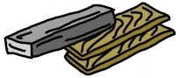
‐Building Materials Waste from dismantling
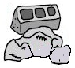
‐Laptops (Contact us for more information on how to recycle.)
‐Tatami Mats
‐Paint Cans (Items with content inside)
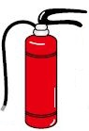
‐Blocks, Metal Pipes, Bricks, and Concrete Debris
‐Bathtub
‐Fire Extinguisher (Contact us for more information on how to recycle.)
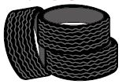
‐Gas Canister
‐Tires
‐Plastic Sheets and Frames for Agriculture / Green Houses
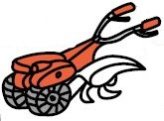
‐Large Net
‐Motorcycles / Motor Bikes (Contact us for more information on how to recycle.)
‐Pesticide
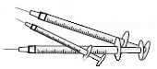
‐Battery
‐Farming Equipment
‐Syringes (Return to the clinic or pharmacy that supplied this item.)

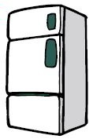
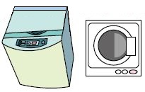
・Home Electronic Appliances targeted for Recycling
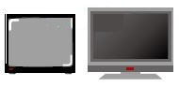
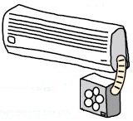
‐LCD and Plasma TVs
‐Refrigerators and Freezers
‐Washers and Dryers
‐Air Conditioning Units (including outside units)
*When the items mentioned above are no longer useable, please use one of the following 3 methods to recycle.
➀When requesting a Retail Store
Request a Retail Store that you have either bought from or plan to buy a Home Electronic Appliance from. (Recycling Fee + Collections Fee)
➁When delivering the item directly to the place of transaction
Transfer the Recycling Fee to a post office in advance, then transport it to the place of transaction personally. (Recycling Fee)
➂When requesting pickup from an agent approved by the Chosei Area Assocation
Transfer the Recycling Fee to a post office in advance, then contact the certified Chosei Waste Disposal Association (℡0475-33-7676) for collection. (Recycling Fee + Collections Fee)

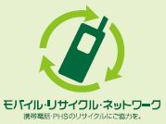
・For phones and PHS systems that are no longer necessary, specialty stores with a designated mark will collect them without extra fees. We thank you for your cooperation in recycling these items.

